GLRLMS {mean of 4 angles} (11) + GLCM (20) + Hu moments (7);

No variables excluded; no PCA; classes 1&2 and 3&4 **NOT** lumped

Tumor slides resized to 100*100 pixels

10-fold cross-validation

1. Best classifier: KNN (k=1)

Accuracy = **95.6%**

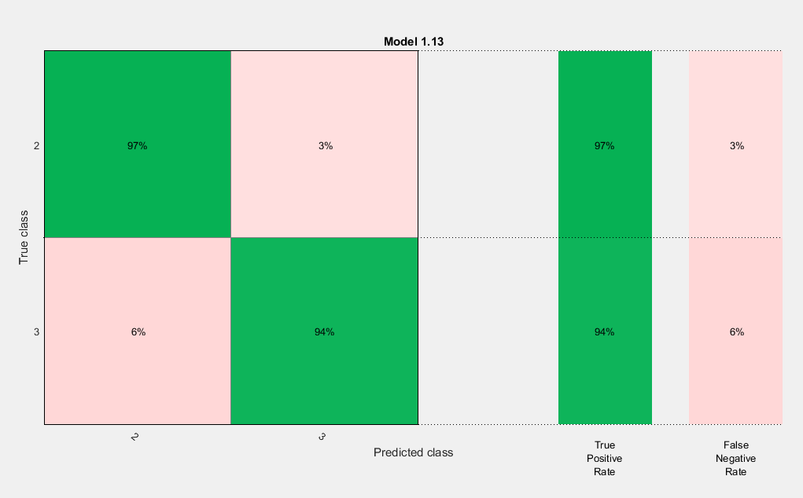

1. Best classifier: KNN (k=1)

Accuracy = **94.1%**

1. Best classifier: KNN (k=1)

Accuracy = **91.2%**

1. Best classifier: KNN (k=1)

Accuracy = **95.6%**

1. Best classifier: KNN (k=1)

Accuracy = **94.1%**

1. Best classifier: KNN (k=1)

Accuracy = **97.1%**

**Average accuracy = 94.62%**

Leave 1 out cross-validation

1. Best classifier: KNN (k=1)

Accuracy = **95.6%**